Next Steps/Flowchart

Summary and Next steps followed by flowchart

We have Questions generated by llm with all the methods(zero,few),Dr yang has human generated questions,list and contents of books except those 8 books(have asked shay to give content)

Next Steps
- First, we will freeze all the datasets so that no further changes are made during the evaluation process.
- Next, we will merge all the CSV files that contain the questions generated by the LLM into a single dataset.
- Then we will perform a human evaluation on the LLM-generated questions based on the design metrics that will be used for assigning scores on a likert scale, identifying each question associated with its respective CROWD type as ground truth.
- Next, we will assess the quality of the human-generated questions with the same assessment framework.
- We will then compute the ROUGE score to measure the similarity between generated questions and the reference questions.
- Following this, we will use an LLM as a judge to automatically evaluate the quality of the questions.
- After that, a machine learning model will be trained on a combination of questions produced by LLM and scores from human assessment.
- Finally, we will test the test machine learning model on human-generated questions and llm generated questions and compare the predictions with the ground-truth labels.

Flowchart
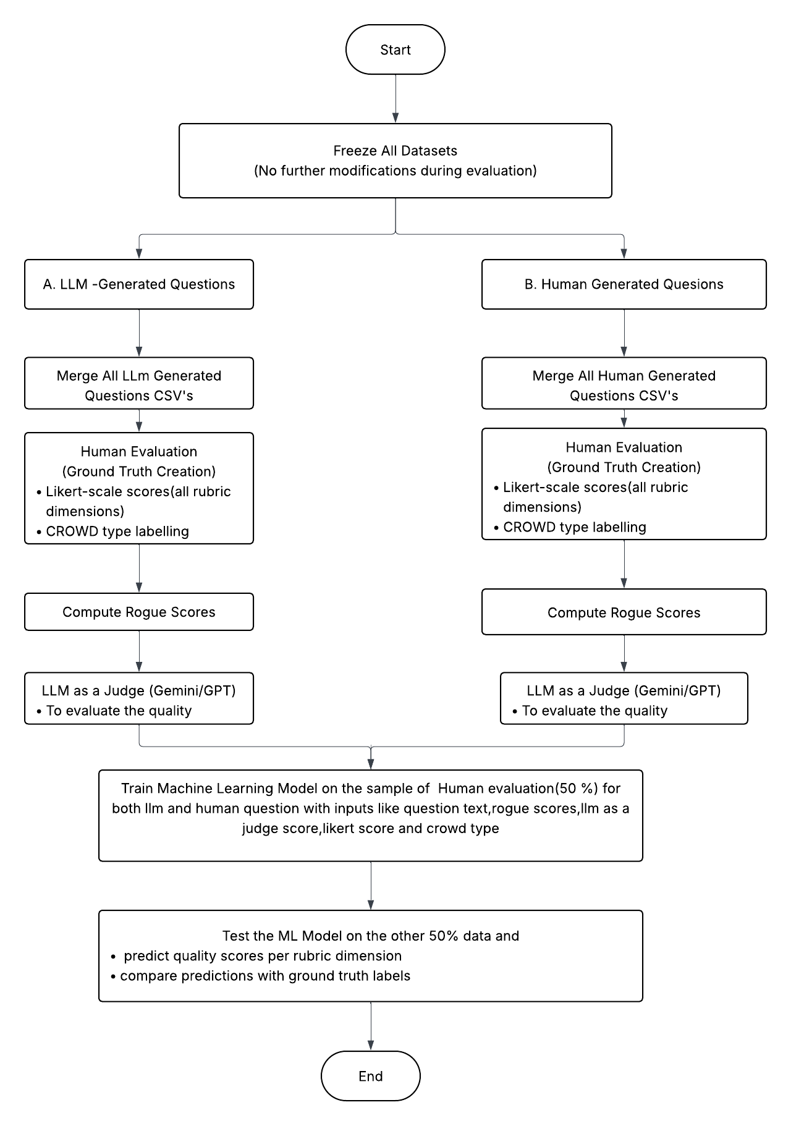

rubrics and paper table
Rubrics table
Rubrics | Reference | Scale(T/f or likert)
Curriculum  Alignment | 2,6,9 | likert
Age  Appropriateness | 6,7,8,11,12 | likert
Crowd framework alignment | 7,8 | both
Engagement &;  Intracavity | 6,7,8 | both
Relevance to  the Text | 2,3,4,12 | likert
Clarity&  Specificity | 1,3,5,10,11,12 | likert
Grammatical  Correctness | 1,5 | both
Difficulty  (Cognitive  Level)  Can be in age Appropriateness | 2,5,7,11 | likert
Answerability | 1,2,3,10,11 | both

Rubric | Definition | Does Not align | Completely Align
CROWD Framework Alignment | Measures whether the generated question correctly follows the intended CROWD category (Completion, Recall, Open-ended, Wh-, or Distancing) according to dialogic reading principles. | 0 | 1

Human Evaluation rubrics

Criteria | Measures | Great (3) | Good (2) | Poor (1)
Curriculum Alignment | Does the question support the learning goal or skill being taught? | Perfectly fits your class topics and curriculum goals. | Mostly aligns but might miss some areas. | Doesn't really match what you're teaching
Age & Cognitive Appropriateness | Is the question suitable for the developmental level, cognitive ability, and vocabulary of the target age group? | The question is well matched to the students’ age, language ability, and cognitive development.. | The question is generally suitable but may be slightly too easy, too difficult, or use vocabulary that may not engage all students. | The question is not suitable for the students’ age group due to inappropriate language, complexity, or cognitive demand.
Engagement & Interactivity | Will students enjoy answering it? Does it promote participation? | Students love using it and actively participate. | Students use it but aren't thrilled. | Students find it boring or hard to engage with.
Relevance to the Text | Does the question actually relate to what is in the text? | Directly related to key ideas in the passage; clearly grounded in the text. | Mostly relevant but may focus on minor or less important details. | Not relevant; includes incorrect information or details not in the text.
Clarity & Specificity | Is the question clear, unambiguous, and exactly asking what it intends? | Very clear, easy to understand, and asks exactly what is intended. | Mostly clear but may contain slightly vague or wordy phrasing. | Confusing, unclear, or too broad; students won’t know what is being asked.
Grammatical Correctness | Is the question grammatically correct? | Grammatically correct and well-structured; reads smoothly. | Small grammar issues but still understandable. | Grammar errors make it hard to understand or unprofessional.
Answerability | Determine if the answer is explicitly present or inferable from the text; the question should not be ambiguous or impossible to answer | Clear, text-based answer; easy for the child to respond correctly. | Mostly answerable; may need small inference or support. | Not answerable from the text; unclear, too hard, or missing information.

1. Panchal, Parth & Thakkar, Janak & Pillai, Veerapathiramoorthy & Patil, Shweta. (2021). Automatic Question Generation and Evaluation. Journal of University of Shanghai for Science and Technology. 23. 751-761. 10.51201/JUSST/21/05203

2.Changrong Xiao, Sean Xin Xu, Kunpeng Zhang, Yufang Wang, and Lei Xia. 2023. Evaluating Reading Comprehension Exercises Generated by LLMs: A Showcase of ChatGPT in Education Applications. In Proceedings of the 18th Workshop on Innovative Use of NLP for Building Educational Applications (BEA 2023), pages 610–625, Toronto, Canada. Association for Computational Linguistics.

3. Deroy, Aniket, et al. “MIRROR: A Novel Approach for the Automated Evaluation of Open-Ended Question Generation.” arXiv, 2025, https://doi.org/10.48550/arXiv.2410.12893.

4.Shinhyeok Oh, Hyojun Go, Hyeongdon Moon, Yunsung Lee, Myeongho Jeong, Hyun Seung Lee, and Seungtaek Choi. 2023. Evaluation of Question Generation Needs More References. In Findings of the Association for Computational Linguistics: ACL 2023, pages 6358–6367, Toronto, Canada. Association for Computational Linguistics.

5.Mulla, N., Gharpure, P. Automatic question generation: a review of methodologies, datasets, evaluation metrics, and applications. Prog Artif Intell 12, 1–32 (2023). https://doi.org/10.1007/s13748-023-00295-9

6. https://blog.tcea.org/rubric-checklist-assessing-ai-tools/

7. StoryPal Paper
8. ContextQ: Generated Questions to Support Meaningful
Parent-Child Dialogue While Co-Reading
9. Naghmeh Farzi and Laura Dietz. 2024. Pencils Down! Automatic Rubric-based Evaluation of Retrieve/Generate Systems. In Proceedings of the 2024 ACM SIGIR International Conference on Theory of Information Retrieval (ICTIR '24). Association for Computing Machinery, New York, NY, USA, 175–184. https://doi.org/10.1145/3664190.3672511

10.Aditya Pathak, Rachit Gandhi, Vaibhav Uttam, Arnav Ramamoorthy, Pratyush Ghosh, Aaryan Raj Jindal, Shreyash Verma, Aditya Mittal, Aashna Ased, Chirag Khatri, Yashwanth Nakka, Devansh, Jagat Sesh Challa, and Dhruv Kumar. 2025. Rubric Is All You Need: Improving LLM-Based Code Evaluation With Question-Specific Rubrics. In Proceedings of the 2025 ACM Conference on International Computing Education Research V.1 (ICER '25). Association for Computing Machinery, New York, NY, USA, 181–195. https://doi.org/10.1145/3702652.3744220

11.Kim, E., Khalil, S., & Shin, H. J. (2025, July). Comparing human and LLM evaluations on AI-generated critical thinking items: Implications for valid applications of automatic item generation. In EvalLAC’25: 2nd Workshop on Automatic Evaluation of Learning and Assessment Content, Palermo, Italy.
12. https://aclanthology.org/2024.findings-eacl.145.pdf

Papers table
Paper Number | Education Focused | Context | Technology(which llm or how)
1 | General – Higher Education (assessment-focused) | Factual wh,fill in the blank,  Simple descriptive,  Basic comprehension | Traditional NLP (templates, rules, keyword extraction). No LLM.
2 | K–12 + general reading comprehension | Reading comprehension exercises, WH questions, inference, factual and reasoning | ChatGPT (GPT-3.5/4) used to generate reading exercises and evaluate difficulty
3 | General education (not age-specific) | Open-ended question generation evaluation; semantic grounding; answerability | MIRROR evaluation model; uses embeddings + scoring. Not LLM-based QG.
4 | General QG evaluation research | Evaluates quality of generated questions; focuses on reference diversity; relevance; clarity | Uses BERT-based models + standard metrics; critiques metrics. No LLM QG.
5 | General education; survey of QG methods | Covers all question types: factual, descriptive, inference, yes/no, MCQ | Surveys techniques: rule-based, seq2seq, transformers. Mentions LLMs but not primary method.
6 | K–12 classroom practice | Rubric for evaluating AI tools: usability, alignment, appropriateness | Not tied to specific LLM; evaluates any AI system, including LLMs
7 | Early Childhood Education (ages 3–7) | Dialogic reading; CROWD-like conversational prompts; text-based guidance for parents | Uses GPT-4 and similar LLMs to generate interactive story prompts
8 | Early childhood & parent–child co-reading | Meaningful WH + distancing-style questions; conversational prompts | Uses GPT-3.5/4 to generate contextually appropriate questions
9 | Higher education + IR systems | Rubric-based evaluation of generated answers/questions; grading rubrics | Uses retrieval models + LLM scoring (GPT-based evaluators)
10 | Computing education; CS assessments | Code evaluation rubrics; correctness, quality, clarity | Uses LLMs (GPT-4, PaLM) to evaluate code using question-specific rubrics
11 | Higher education; assessment design | Critical thinking items, difficulty levels, clarity, answerability | Compares human scoring vs LLM scoring (GPT-4)
12 |  | Evaluates generated items; readability; relevance; error analysis | Uses transformer LLMs (GPT, BERT-based) for evaluation & generation
  General NLP education + evaluation

Tab 3
Research gap
No standardized framework for evaluation question for early age

Question
Are we doing rogue score only for automatic generation
And

Contributions-
- Rubrics
- To evaluate llm generated questions
- To evaluate human generated questions
- Llm as a judge
- Evaluate human questions with some llm/ml model

Summary-

